Contact: Jim Bonnardel  Silent Electric Flyers of San Diego  Phone 858.354.2618  nitroblast@hotmail.com | 812 Sea World Drive  San Diego Ca | Silent Electric Flyers of San Diego
Press Release

International Drone Day

The Press, and Public is welcome to come down and visit, learn about, and watch Radio Control Multi Rotor Aircraft commonly referred to as “Drones”
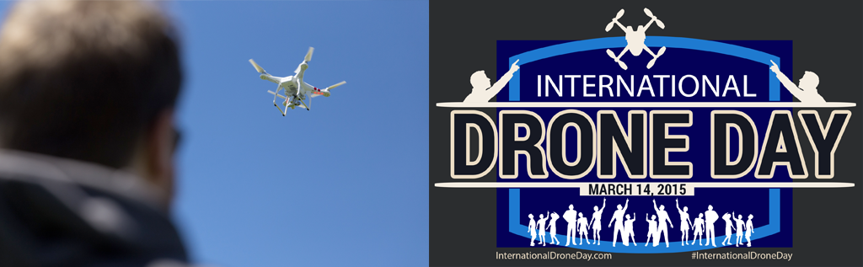

San Diego Ca, November 14, 2015:
- Contact Jim Bonnardel at 858.354.2618 for more information
- The Silent Electric Flyers is San Diego’s premiere radio control flying field with over 325 members
- Sanctioned by the Academy of Model Aeronautics
- 10:00 am through 2:00pm Saturday March 14th, 2015
- 812 Sea World Drive, San Diego CA 92109

Drones have a bad reputation, and even though many of us call Multi-rotors by different names, the public does associate these fantastic machines with the word drone. We are here to make sure that Drones are seen in a positive light.

International Drone Day is held every year on the second Saturday in the Month of March. This year is will be held on March 14, 2015 with Las Vegas being the host city.
The purpose of International Drone Day is to show the world that drones are good, and can be used for many good purposes. Movie making, search and rescue, police work, architecture, inspections, emergency response, and for just having fun.

Groups of drone enthusiast get together into organized groups all across the world to fly their drones, and invite friends, neighbors, and the media to showcase drones in a good way

Drone Day Team San Diego Events Description

Auto Land:
This is a single pilot at a time event. This event is simple. Pilot takes off from a marked area and flies 200ft or so away (not critical distance). Puts craft in “Auto Land”, RTH (return to home) or RTL (return to launch) mode. Pilot with the shortest distance from take-off point wins.

Obstacle Course:
This is a single pilot at a time event. Pilot must navigate through 4 PVC obstacles and return to the take-off location. Timer is used for scoring. Shortest time wins. Watch a demo video at: http://youtu.be/EPoZ0KgGJHA

Drone Day Team San Diego Events Description (cont.)

Search and Rescue:
This is an “All Up” event. All pilots fly at the same time (pending any FPV frequency conflicts). If there are FPV frequency issues, multiple rounds can be flown. Timer is used for scoring. Shortest time wins. Pilots all search for 4 different white signs (24” x 36”) placed out in the flying area, and are not easy to locate. Each sign has a number on it in black paint. First pilot to return with the total sum of all numbers wins prize.

Altitude Quest:
This is a single pilot at a time event. Pilot spins electric game ‘spinner’ and gets a number from 100 to 399 in increments of 50. 399 is used because AMA dictates a 400ft altitude cap, and we do not want to promote flying above 400ft. An electronic altimeter is placed on the craft, and the pilot uses Line of Sight, with no electronic assistance to approximate his altitude closest to his random number. Pilot getting closest to the target altitude wins prize.

Line of Sight Race
Bracket Racing style race. Number of persons in each race is determined by number of participants on the day of the event. Races of 2 to 4 pilots are done around 2 turn marker flags for 5 lap race. A turn cut results in loss of lap unless pilot makes up the turn. Winner advances to main event. Winners of heat race compete for prize.

FPV Race (first person view via camera)
Bracket Racing style race. Number of persons in each race is determined by number of participants on the day of the event. Races of 2 to 4 pilots are done around 4 turn marker flags in road course style for 5 lap race. A turn cut results in loss of lap unless pilot makes up the turn. Winner advances to main event. Winners of heat race compete for prize.

