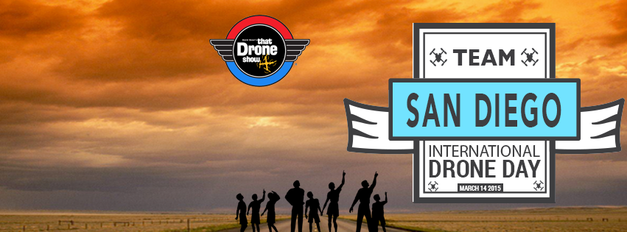

Team San Diego Sign-Up Sheet
Name ____________________________________
Address ____________________________________
____________________________________
Phone ____________________________________
AMA # ___________________

Drones You Will Fly FPV Freq. & Ch. __________________________ ____________
__________________________ ____________
__________________________ ____________
__________________________ ____________

EVENTS YOU WILL PARTICIPATE IN:
[ ] FPV Race [ ] LOS Race
[ ] Search and Rescue [ ] Auto Landing Challenge
[ ] Obstacle Course [ ] Altitude Quest
Complete and return to: nitroblast@hotmail.com

